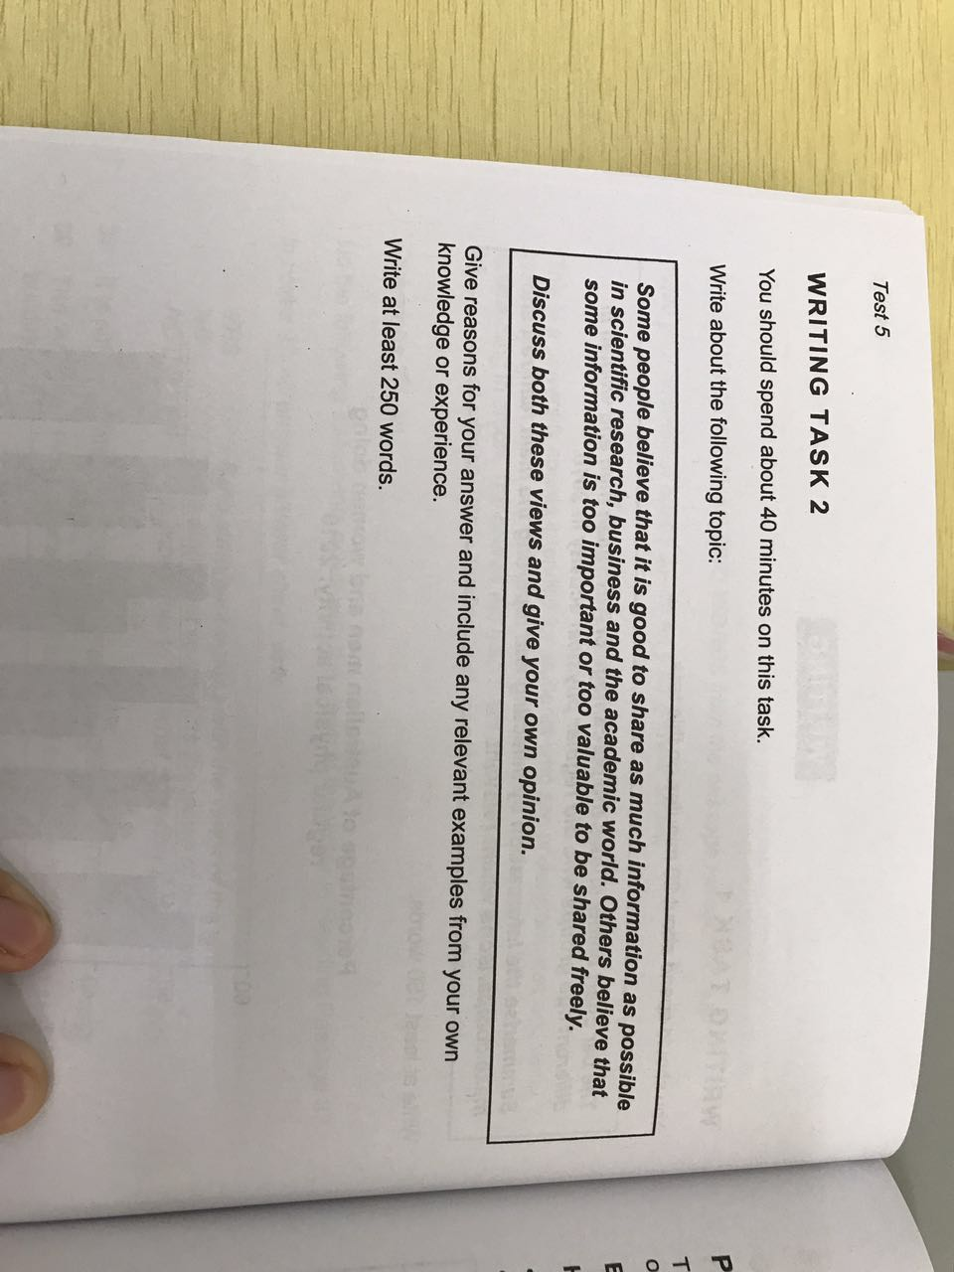

The issue of information sharing is becoming increasingly severe. This trend has encouraged people to discuss the topic that if information should be shared freely or not. This essay will discuss the arguments from both sides

Some individuals tend to think that sharing is absolutely positive to works about science. Firstly, other people’s opinions may be hard to understand without explains and backgrounds, they can provide a more accurate view to the whole research, therefore, it is important to clean every barricade in information sharing. Moreover, cooperating with other people or groups could often increase the speed of research, which is helpful especially when facing problems that need to be solved as soon as possible. However, if the latest progress cannot be synchronized, this advantage will disappear.

Of course, there are other people holding opposite opinion. They like the idea of not sharing everything they know. Basically it is because sometime business or military secrets are involved and they cannot risk the danger of leaking those data, which is common in cooperation between companies or countries. Besides, individuals are often not able to trust others completely, as a result, it is common to protect the core information from being studied.

As a summary, at most of the times, sharing information freely during cooperation is absolutely the best option, but keeping critical data safe from threat is also important. If people could trust others while cooperating, the efficiency will surely be the highest.